CAD STANDARD

Description of the standard file:

*This “CAD Standard” document has to be used by the teams as a reference when creating their parts, drawings and assemblies on Solidworks. This file will include some basic good practices when modelling that will be very helpful* ***when the components will be assembled by the System Integrator*** *but also if there will be any* ***need of changing dimensions in an efficient way****.*

*All the team members responsible for the modelling have, therefore, to follow the rules for this file.*

Main guidelines for modelling:

* Use the same format for every part: .sldprt (no .step files must be sent to the SI for the assembly)
* Possibly use a common reference system, such as:
  + **top plane** corresponds to the “horizontal plane”
  + **front plane** corresponds to “vertical plane”, whose vector points in the rotor axis direction
  + **right plane** corresponds to the “vertical plane”, whose vector points perpendicular to the rotor axis direction
* Refer everything to existing planes inside of the model   
  (avoid external references)
* In the assembly try to refer everything to the existing assembly planes
* Do not use screws in the assembly because they can be complicated to deal with and they reach very high amounts
* Use the same unit for all the dimensions: **mm**

Main suggestions for modelling

* Try to use as simple features as possible
* When creating your part based on a model uploaded from the internet (or receive it from a company), please try to make sure that the model gets changed and that it is not too detailed: it could result in a problem for the whole assembly!
* In general do not exaggerate with the details (unless it is gearbox, bearings or pitch system but, f.e., it is not necessary to make the detailed modelling internal side of the drives)
* Always try to follow a logic structure for the creation of models and always have in mind that you have to be able to modify some dimensions later, so make sure that your structure is suitable for that
* Try to use folders and dynamic reference visualization schemes to avoid confusion in the parent/child structure of the features
* **A template for PART will be uploaded to GitHub (and soon one for assembly**

File uploading and ordering

Since the solidworks files are very heavy the files must be sent to the System Integrator directly as a **.zip file (DO NOT UPLOAD THEM ON GITHUB FOR NOW!!)** . The files must be structured in the following way: 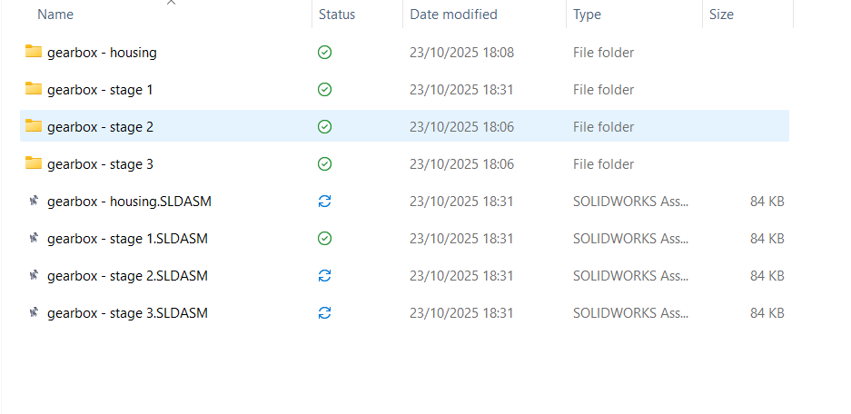

1

2

Figure - structure of the zip file

1. Folders with parts of the different sub-assembly

Insert all the different components for the assembly in this folder and call them in a way that is universally recognizable

Figure - what is contained by the folder 'Gearbox - stage 1'

1. Assemblies of the components in the folders

As it can be seen in Figure 1 call the folders in an universal way that can be easily identified.

PLEASE UPDATE THE STATUS OF THE COMPONENT IN THE “result file.xlsx” IN THE “list of components” SHEET:

